The Antarctic Peninsula – 12 Days
Aboard “Hebridean Sky” and “Island Sky”
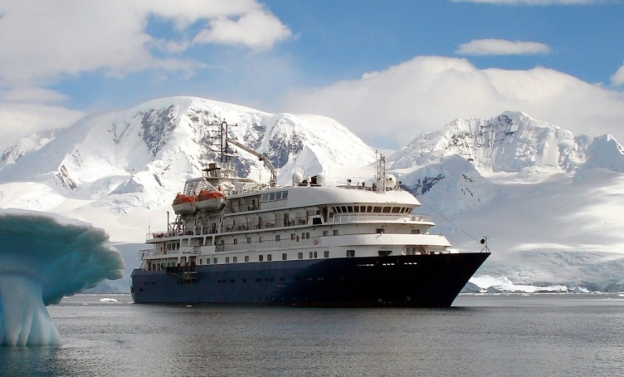

Departures
Dec 18 – 29, 2018 / Island Sky
Dec 28, 2018 – Jan 8, 2019 / Island Sky
Jan 18 – Jan 29, 2019 / Hebridean Sky
Jan 07 – Jan 18, 2020 / Hebridean Sky
Feb 04 – Feb 15, 2020 / Hebridean Sky

Day 1, Ushuaia:

Enjoy the Argentinean leather markets and succulent lamb dishes that make Patagonia famous as you explore the southernmost town in the world. Highlights of Ushuaia include an award-winning museum and trips to nearby Tierra del Fuego National Park and its popular “Train at the End of the World”.

Day 2, Embarkation:

Arriving at the ship in the afternoon, you will be greeted by our Expedition Team and ship's officers at a safety and orientation briefing followed by the Captain's welcome dinner. After dinner, relax and take in the mountainous scenery on our early evening sail down the Beagle Channel past Magellanic Penguin, Rock Cormorant, and Sea Lion colonies.

Day 3-4, Drake Passage:

Among the wildlife spotting opportunities as we sail south are the Albatrosses, Prions, and Petrels that frequently follow the ship. Our Expedition Team will be out on deck as well, looking for the Whales and Dolphins that may also be seen in the area. Our experts will hold informative and entertaining presentations on the wildlife, history, and geology of Antarctica. Helpful briefings on environmental regulations and expedition safety will also be held in the comfortable lounge. The length of our journey depends on sea conditions but we should approach the South Shetland Islands of the Antarctic Peninsula in the evening of Day 4.

Day 5-9, Antarctica:

The land of superlatives, Antarctica! Our Expedition Leader and Captain will create a flexible itinerary based on weather, ice, and opportunity. The route will stress the most scenic bays and channels of the Peninsula with stops at penguin rookeries, seal wallows, bird colonies and whale feeding areas as well as sites of historic and scientific interest. The trip may include picturesque Neko Harbor, sheltered Paradise Harbor, the Humpback Whale favored Wilhelmina Bay, the striking Lemaire Channel, the wildlife-filled Penola Channel, or the majestic Neumayer Channel. We may stop at an active scientific base such as Poland’s Arctowksi or Ukraine’s Vernadskiy as well as an historic base such as U.K.’s Port Lockroy or Wordie House. Adelie, Chinstrap and Gentoo Penguins abound, and Weddell, Crabeater and Elephant Seals are often found hauled out to rest along with predatory Leopard Seals and the aggressive Antarctic Fur Seal. Minke and Humpback Whales are frequent visitors in the late season and Orca sightings are also common.
Day 10-11, Drake Passage:

We will continue our presentation series and wildlife spotting as we sail back to Ushuaia and reflect on beautiful Antarctica and its fragile future. We arrive at Ushuaia in the early hours of Day 12.

Day 12, Ushuaia disembarkation:

Morning disembarkation lets you catch a flight to Buenos Aires or stay in Ushuaia for more sights and adventure.

